Data Science Project
Brendan Bloss
Professor Name: John Cook
NHTSA Motor Vehicle Collision Data
April 22, 2025

Executive Summary
In the United States, there are nearly 120 traffic fatalities on average each day, and Over 40,000 people die in a MVC each year in the U.S (CDC, 2024). Although 40,000 people lose their life from traffic fatalities each year, significantly more than 40,000 people are affected by motor vehicle collisions resulting in a fatality because of debilitating injuries sustained in a collision by survivors, and the families of crash victims are affected as well. Moreover, motor vehicle collisions cost taxpayers a combined 340 billion dollars each year. Lastly, motor vehicle collisions resulting in fatalities burden the victim’s family from lost wages due to lost time from work, losing a spouse who provides for the family, and financial hardship are all concerns that extend well beyond 40,000 people each year.
In order to reduce the number of traffic fatalities, the collision types with the highest number of fatalities will be investigated. Investigating the causes of the most dangerous collision types is more useful than predicting the number of fatalities in each collision since different steps can be taken to address each specific collision type. The most common collision in the dataset involving another motor vehicle in transport were angle collisions which are most commonly found at 4-way intersections and T-intersections. Collisions involving a struck pedestrian also have high fatality counts. Proposed solutions to reduce the number of angle collisions include installing a roundabout at 4-way intersections that have a high count of angle collisions and where traffic volume isn’t too high, and by eliminating unprotected left turns from businesses and streets along arterial routes (Ferguson & McCartt, 2003). Proposed solutions to reduce the number of pedestrians struck by a motor vehicle include using speed humps or narrowing road lanes to reduce vehicle speed, installing pedestrian fences between road medians to eliminate jaywalking, and by removing on street parking and implementing diagonal parking on streets where parked vehicles are commonly struck (Ferguson & McCartt, 2003).
Researching the most common causes of motor vehicle collisions resulting in at least one fatality are important when coming up with solutions so the right solution can be implemented. Although excessive speeding, distracted driving, and aggressive driving are big contributors to collisions in the dataset, road design is also an important contributor. Therefore, finding ways to get drivers attention and upgrading roads to reduce specific collision types and increase walkability are the next steps in reducing traffic fatalities.
Table of Contents
Project Scope 4
Problem Description 4
Project Importance 4
Background 4
Data Set Description 4
Data Analytics Tools 4
Project Milestones 4
Completion History 5
Lessons Learned 5
Data Profiling and Preparation 6
Data Summary 6
Data Definition/Data Profile 6
Data Preparation 6
Data Visualizations 7
Descriptive Statistics 7
Data Visualization Definitions 7
Data Visualization 1 7
Data Visualization 2 7
Data Modeling 8
Data Modeling Definitions 8
Data Model 1 8
Data Model 2 8
Review of Data Models 8
Final Results 9
Findings 9
Review of Success or Completion 9
Recommendations for Future Analysis 9
References 10

Project Scope
Assignment 1

Problem Description
The dataset that will be analyzed is the National Highway Transportation Safety Administration (NHTSA) traffic fatality dataset from 2022. Fatalities from motor vehicle collisions (MVC) have been on the decline for the past 30 years due to improvements in vehicle design and safety but have stalled within the past decade (U.S. Department of Transportation, 2023). In 2022, 42,514 people died in a MVC on U.S. roadways, a trend that has recently been increasing each year (U.S. Department of Transportation, 2023). Roadway fatalities began to consistently increase after 2014 and peaked in 2021 at 43,230, which is the highest it’s been since 2005 (U.S. Department of Transportation, 2023). Another way to look at this is that for every 100 million vehicle miles traveled in 2021, there were 1.37 deaths which is a 2.2% increase from 2020 (Stewart, 2023). Using an alternative means of transportation such as walking or cycling has also become more dangerous as the mortality rate of pedestrians struck by a motor vehicle has increased from 20% in 1996 to 34% in 2021 (Stewart, 2023).

This is a concerning problem because traffic fatalities are one of the biggest causes of death among young adults. The United States loses on average 120 people each day in MVC’s and Over 40,000 people die in a MVC each year in the U.S (CDC, 2024). Significantly more than 40,000 people are affected because of injuries sustained in a collision and the families of crash victims are affected as well. Lost wages due to lost time from work, financial hardships, and losing a husband who provides for the family are all concerns that extend well beyond 40,000 people each year. Furthermore, fatal MVC’s resulted in an estimated loss of 470 billion USD which includes medical costs, damage costs, and cost for lost lives (CDC, 2024). Commuting to and from work each day to provide for one’s family should not pose a significant safety risk, which is what this project is going to research, road safety.

Final Statement for paragraph: The data analytics problem that I am analyzing is THEN IN YOUR OWN WORDS DESCRIBE

Project Importance
The United States loses over 40,000 people each year to MVC’s and MVC’s cost taxpayers a combined 470 billion USD each year which is why it is important to research data on the causes of fatal MVC’s (CDC, 2024). These costs include medical costs, lost productivity, legal/court costs, emergency service dispatch costs, insurance costs, and property damage (Blincoe et al, 2023). In 2019, fatal MVC’s cost taxpayers an estimated 340 billion USD which is roughly $1,035 per U.S. citizen. More importantly, MVC’s cause premature deaths and loss of quality of life for individuals who survive serious collisions (Blincoe et al, 2023). MVC’s raise the cost of health insurance for everyone through higher premiums and the diversion of medical needs away from other areas such as research or disease prevention and control which is how society as a whole is impacted by fatal MVC’s (Blincoe et al, 2023). Furthermore, the victims dependents can suffer financial hardship as they can no longer work and taxpayers are burdened as more of their tax money goes towards supporting disability payments for crash victims (Blincoe et al, 2023).
The most significant costs related to MVC’s are lost market productivity and property damage which includes vehicle damage and other property damaged in the collision (Blincoe et al, 2023). Moreover, responding to MVC’s is one of the most common dispatch calls for EMS and fire departments which rely on taxpayer money to function. Lastly, congestion caused by MVC’s causes more fuel consumption and therefore adds more pollution to the air people breathe worsening health conditions such as asthma (Blincoe et al, 2023). Therefore, the data shows that even people uninvolved in a MVC are impacted which is why researching the causes of MVC’s is important.
Provide at least at least 2 paragraphs with 6 sentences each. Provide citation and reference from scholarly journal to support project importance.

Background
Motor vehicle crashes are one of leading causes of mortality in the United States. Fatal MVC’s can be caused by distracted driving, speeding, or driving under the influence but Americas roadway design and infrastructure has a huge impact on the count of fatal MVC’s each year. Policies regarding the design of the nations transportation infrastructure has supported infrastructure that supports motor vehicles and has underinvested in infrastructure that supports walking and cycling (Dadashova et al., 2024). Many municipalities have roads that serve to move traffic quickly but also have businesses such as fast food and retail shops along them. This is dangerous to commuters as there are many turning vehicles on roads designed for high-speed leading to more collisions. The primary goal of Americas transportation system is to move as many people as possible through motor vehicle transportation (EA, 2023). When this is the goal, other projects such as providing sidewalks for pedestrians and bike lanes for cyclists are not prioritized and budgeted (EA, 2023). This has led to a 13% increase in mortality for pedestrians between 2020 and 2021 and a 5% increase for cyclists struck by a vehicle (EA, 2023).

Modern day projects to increase traffic flow such as diverging diamond interchanges combat congestion, but pedestrians are usually an afterthought when it comes to redesigning intersections like diverging diamond interchanges (EA, 2023). Moreover, roads may be widened to increase traffic speed and flow. This is especially dangerous on roads that have many unprotected left turns as making a left turn onto a busy undivided road with two lanes in each direction is very dangerous. This shows that when it comes to analyzing fatal MVC’s, road and intersection design must be studied because speed and efficiency comes at a cost which is that roads become more dangerous.
Provide at least 2 paragraphs with 6 sentences. Provide citation and reference from scholarly journal to support project background.

Data Set Description
The proposed data set is from the National Highway Transportation Safety Administration (NHTSA). It includes MVC statistics from the year 2022. The NHTSA dataset collects data from motor vehicle collisions (MVC’s) with at least one death from across the country and records them on a spreadsheet. The data includes date information such as month, day, and time of day. There is also location data that includes the latitude and longitude, state, county, city (if applicable), if it the collision occurred in an urban or rural area, and lastly the road mile marker (if applicable). Data on the roadway where the MVC occurred is also collected. This includes the name of the roadway, route type (state route, U.S. route, interstate), and its function (arterial, interstate, major collector). Other data collected includes weather conditions, type of collision (tree hit, rollover, pedestrian hit, etc…), type of intersection (if applicable), light conditions (daylight, dark-lighted, dark-unlighted, dawn), if there was a school bus involved, and number of fatalities.

Data Analytics Tools
I plan on using either Microsoft Excel or Python to clean the data and make sure it is accurate. I will also use SQL to gather insights on the data. This may include number of fatalities per state, most common type of fatal collision. Other useful insights that SQL can help find are the number of fatalities in each roadway function such as an arterial route or interstate and compare them.
I plan on using Tableau to create an interactive dashboard that displays the results of my findings. Lastly, I will create a presentation using Microsoft PowerPoint and display the tableau dashboard on the presentation.

Project Milestones
Describe the major milestones you will perform for this Project.
The first step is to research the topic and become familiar with the traffic fatalities dataset. Researching the information on traffic fatality causes will add context to the problem so it can be understood better. The next step involves preparing the dataset so it can be analyzed. This is an important step because it removes errors from the dataset such as incorrect outliers or incorrect values. This step can be done using Excel or a programming language such as SQL or Python. Preparing the data will ensure the most accurate results when further analyzing it.

The next step is to plan and build the model. In this step, data analysts find trends between key variables and splits the data into training and testing sets. Training the model will allow it to accurately predict new data points that are not yet seen.

Lastly, the results are analyzed, and I will see if the results make sense or if the model needs further adjustments. In the case of the dataset I’m using, the model should be able to predict “hotspot” sites for fatal car accidents which is the most common locations where fatal car accidents occur, and the confounding variables that contribute to fatal MVC’s such as weather, reduced visibility, function of road, route type, and if the location is in an urban or rural area. Having this information will allow me to present the solution to the problem of increasing fatal MVC’s and propose solutions to reduce the amount of fatal MVC’s in the future.

Completion History
Assignments 1 - 5
Weeks 1 & 2 | Picked a dataset on traffic fatalities in the US 2022 and did some background research on the topic. This includes why the problem is important and why it should be researched.
Weeks 3 & 4 | Analyzed the dataset and gave a description of each variable. Cleaned the dataset by removing errors and some unknown values. I also modified the data set by removing columns that had inaccurate data or were irrelevant. I then created data visualizations in tableau to see the effect the variables had on number of fatalities.
Weeks 5 & 6 | Built a decision tree and Naïve Bayes model to classify the type of collision each collision was. The collision could either be classified as an angle collision, head-on collision, rear-end collision, sideswipe, rear to side, or no collision with another motor vehicle. Ultimately decided on using collision type as the target variable instead of number of fatalities since the heavy majority of collisions in this dataset resulted in only one fatality, so the model would always predict one fatality for each instance. A Naïve Bayes model was chosen over a support vector machine because it is easier to set up and there can be more than two target classifications with a Naïve Bayes model. A decision tree was also chosen because of its explainability.
Weeks 7 & 8 | Researched ethical concerns related to the dataset and established the importance of ensuring that the data collected from the investigation is secure. I also researched the potential consequences of what could happen if the data is misused such as setting up unwanted speed traps and targeting minority communities with anti-crime efforts. Other tasks completed included reviewing the success of the project and if it met its goals and established what should be researched in the future using this or a similar dataset.

Lessons Learned
Assignments 1 - 5
Assignment 1 | Having knowledge on the topic related to the dataset is important because it gives context to the dataset. Without doing adequate research, you won’t understand the relationships between variables and how they affect each other or the target variable. Doing background research will also make it easier to find solutions if you know which attributes have the biggest influence on the target variable.
Assignment 2 | Most of the categorical variables had a column right next to them where the variables were encoded into numerical values. When cleaning the data, there were outliers in the pedestrian’s involved column, and most of the categorical values had some unknown values. For this reason, I did not want to delete rows that had unknown values.
Assignment 3 | A lot of fatal collisions did not involve multiple vehicles but the most dangerous collision type that involved 2 or more vehicles are angle collisions and head on collisions. However, the most dangerous collision type may be different depending on the road function. On arterial routes, angle collisions result in the most fatalities but head on collisions result in the most fatalities on interstates. The three states that had the most traffic fatalities were Florida, California, and Texas. Also learned that 4 – way intersections and T-intersections had the most fatalities among intersection types.
Assignment 4 | If the target variable in the dataset isn’t evenly distributed, then the model will have a hard time generalizing unseen datapoints or instances where the target variable category is rare. In the NHTSA dataset there were less than 50 rear-to-side collisions, and the model did not predict any of the collisions to be rear-to-side collisions when testing. However, the model was able to predict collisions where another motor vehicle was not struck with 100% accuracy because that is the most common collision type in this dataset.
Assignment 5 | Before completing this assignment, I assumed that since the data did not have any personally identifying information, it does not need to be secure. Some data such as name or phone number may have been collected but not present in this dataset. Furthermore, if this data is sold to third parties such as medical providers or attorneys, they may call the crash victims, leading to distrust between the crash victims and the highway patrol that collected the data. The main message is that it is important to take steps to ensure that data is secure from outsiders and that it is used for its intended purposes.

Data Profiling and Preparation
Assignment 2

Data Summary
The NHTSA traffic fatality dataset was retrieved from NHTSA database. The data is retrieved from police reports and data the crash investigators provide (Crash Investigation Sampling System). Whenever a fatal MVC occurs, a crash investigation team is usually sent out to investigate the cause of the collision and collect evidence and data such as skid marks struck objects, vehicles involved, and crash damage (Crash Investigation Sampling System). The people involved in the collision may also be interviewed and medical injuries sustained in the collision may be documented (Crash Investigation Sampling System). There are 39,222 rows and 80 columns in the dataset. This means that there were a total of 39,222 fatal MVC’s in this dataset. Although there are 80 columns in the dataset, some of the columns measure the same thing. For example, MAN_COLLNAME records the type of collision that occurred, and the column MAN_COLL assigns an id number to each type of collision (1 = rear-end, 2 = head on, etc.…). The dataset only includes fatal MVC’s in the US from the year 2022.
The dataset is important because it gives key insights into the conditions in each fatal MVC such as weather, light levels, or road type/road function. This data can be used to generate a machine learning model that can predict the likelihood of an individual being involved in a fatal MVC. The NHTSA uses this data to make roads safer by identifying emerging highway safety problems and assessing the effectiveness of motor vehicle standards and highway safety programs (Crash Investigation Sampling System). Strategies to reduce motor vehicle fatalities can then be implemented by implementing safety features in high crash areas. This could mean installing bike lanes, pedestrian crosswalks, rumble strips when approaching a busy intersection, flashing lights to warn motorists of cross traffic or a congested area ahead, or it could mean installing arrow signs at a sharp turn. If the data suggests that speed is a contributing factor, then the speed limit can be reduced. Knowing the contributing factors for fatal MVC’s is important information when attempting to make roads safer, which is why this dataset is important.

Data Definition/Data Profile
Provide a table describing each field/variable including definition, data type, outliers, frequency of nulls, potential quality issues.
Variable | Definition | Data type | Outliers | Unknown values | Quality issues/notes
State name | State collision occurred in | Categorical | x | none | none
ST_case | Id that serves as a unique identifier for each collision | Continuous | x | none | none
PEDS | Number of pedestrians involved in collision | Continuous | 73, 23, 20 | None | None
VE_total | Total number of vehicles involved in collision | Continuous | 50 | None | None
PVH_INVL | Passive vehicle involvement. When a vehicle is involved in a collision without being the primary cause. | Continuous | None | None | None
Persons | Number of people involved in the collision. | continuous | 128 | None | None
County name | Name of county where vehicle collision took place | Categorical | x | None | None
county | Encoded version of county name. each county was given a unique number to identify it. | Discrete | x | 2 | None
City Name | Name of city collision occurred in if applicable | Categorical | x | 8 | If collision did not occur in a city it is listed as N/A
City | Encoded version of city | Discrete | x | 8 | If collision did not occur in city, value = 0. Of value is unknown then 9999.
Month | Month collision occurred in numerical form | Discrete | x | none | none
Month name | Name of month collision occurred | Categorical | x | none | none
Day | Day of month in numerical form collision occurred. | Discrete | x | none | none
Day_Weekname | Day of week collision occurred | Categorical | x | none | none
Day_week | Encoded version of week collision occurred | Discrete | x | none | none
Year | Year collision occurred | Continuous | none | none | Every data point in this dataset is from 2022.
Hour | Hour of day collision occurred in numerical format | Discrete | x | none | none
Hourname | Hour of day collision occurred in time format | Categorical | x | none | none
Minute | Minute of hour collision occurred | Discrete | x | none | none
TWAY_ID | Name of road or route number (ex, I-95) where collision occurred | Categorical | x | 7 | none
TWAY_ID2 | Secondary name of road or highway | Categorical | x | 29,336 | Most roads in this dataset do not have a secondary name so therefore, the row is blank.
RouteName | Classification of route collision occurred on (U.S. route, interstate) | Categorical | x | 837 unknown values
Route | Encoded version of RouteName | Discrete | x | 837 | Route = 9 if route is unknown
RUR_URBName | Records if the collision occurred in a rural or urban area | Categorical | x | 197 | none
RUR_URB | Encoded version of RUR_URBName | discrete | x | 197 | none
FUNC_SYSName | Describes the function of the road collision occurred on (arterial, collector, interstate) | Categorical | x | 331 | none
FUNC_SYS | Encoded version of Func_sysname | Discrete | x | 331 | None
RD_OwnerName | Owner of road collision occurred on. This can be the state, a county, a city, or other agency. | Categorical | x | 4,668 | None
RD_Owner | Encoded version of RD_OwnerName | Discrete | x | 4668 | None
NHS_Name | Records if collision occurred on national highway system | Categorical | x | 267 | None
NHS | Encoded version of NHS_Name | Discrete | x | 267 | none
SP_JURNAME | Special jurisdiction where collision occurred such as a college campus | Categorical | x | 36 | none
SP_JUR | Encoded version of SP_JUR | Discrete | x | 36 | None
MILEPT | Mile point collision occurred at (whole number) | Continuous | None | 10,860 | None
Latitude | Latitude collision occurred at | Continuous | None | none | none
Longitude | Longitude collision occurred at | Continuous | None | None | None
Harm_EVNAME | Records The primary event of the collision such a struck tree, collision with another vehicle, or vehicle rollover. | Categorical | x | 37 unknown objects | None
HARM_EV | Encoded version of HARM_EVname | Discrete | x | 37 | None
MAN_COLLName | Records the type of collision with another vehicle if applicable | Categorical | x | 136 | none
MAN_COLL | Encoded version of collision type | Discrete | x | 136 | None
REJECT1 Name | Records if vehicles involved in collision met or did not meet vehicle safety standards | Categorical | x | 89 | None
REJECT1 | Encoded version of REJECT1 name | Discrete | x | 89 | None
REJECT2NAME | Records location on road where collision occurred at such as an intersection, on/off ramp, rail crossing, flyover ramp, or non-junction | Categorical | x | 39 | None
REJECT2 | Encoded version of REJECT2 name | Discrete | x | 39 | None
TYP_INT Name | Type of intersection collision occurred at | Categorical | x | 192 | None
TYP_INT | Encoded version of TYP_INT Name | Discrete | x | 192 | none
REL_ROADNAME | Records where collision occurred on road such as the median, shoulder, parking lot, turn lane, or on the road. | Categorical | x | 84 | None
REL_ROAD | Encoded version of REL_ROAD name | Discrete | x | 84 | None
WRK_ZONENAME | Records type of work zone collision occurred at such as maintenance, construction | Categorical | x | 287 | None
WRK_Zone | Encoded version of WRK_ZONE name | Discrete | x | 287 | None
LGT_CONDNAME | Light conditions on roadway where vehicle occurred | Categorical | x | 310 | None
LGT_COND | Encoded version of LGT_COND name | Discrete | x | 310 | None
WEATHERNAME | Weather conditions at the time of collision | Categorical | x | 1534 | None
WEATHER | Encoded version of WEATHER Name | Discrete | x | 1534 | None
SCH_BUSNAME | Records if a school bus was involved in the collision | Categorical | x | None | None
SCH_BUS | Encoded version of SCH_BUS name | Discrete | x | none | none
RAILNAME | Name of railroad where collision occurred at if collision occurred at a rail crossing | Categorical | x | 23 | None
RAIL | Encoded version of RAILNAME | Discrete | x | 23 | None
NOT_HOURNAME | Name of hour in time format EMS was notified of collision | Categorical | x | 21,756 | None
NOT_HOUR | Hour of day EMS was notified | Discrete | x | 21,756 | None
NOT_MINNAME | Minute of hour EMS was notified of collision | Discrete | x | 22,494 | None
ARR_HOUR | Hour of day EMS arrived on scene | Discrete | x | 22,314 | None
ARR_HOURNAME | Hour of day EMS arrived on scene in time format | Categorical | x | 22,314 | None
ARR_MINNAME | Minute of hour EMS arrived on scene | Categorical | x | 22,923 | None
ARR_MIN | Minute of hour EMS arrived on scene. (Unknown values encoded) | Discrete | x | 22,923 | None
HOSPITL_HRNAME | Hour of day patient arrived at hospital in time format | Categorical | x | 22,314 | None
HOSPITAL_HR | Hour of day patient arrived at hospital. | Discrete | x | 22,314 | None
HOSP_MINNAME | Minute of hour patient arrived at hospital | Categorical | x | 16,171 | None
HOSP_MIN | Minute of hour patient arrived at hospital (unknown values encoded to 99). | Discrete | x | 16,171 | None
FATALS | Number of fatalities that resulted from the vehicle collision | Continuous | none | none | none

Data Preparation
The first step was analyzing the raw data using Excel and Power BI query editor. The data did not have any errors after analyzing it in Power BI query editor, but a lot of columns had unknown values or outliers. Since the data did not have a ton of outliers, I was able to clean it in Excel table. I deleted some outliers in the pedestrian’s column. Rows where PEDS > 10 were deleted since it is unlikely that this many pedestrians would be involved in a MVC. Only three rows in the entire dataset had PEDS > 10.
Rows that involved rail crossing where the rail crossing is unknown were also deleted. The columns MILEPT and MILEPTNAME were deleted from the dataset because there were a lot of null values and many roads in the dataset did not have mile points. Next, 303 rows were deleted because the time of the incident was unknown in these cases. Knowing the time of the collision is important since it can give insights into the most common time fatal MVC’s occur. Lastly, I deleted all rows where the vehicle total = 0 because it is impossible for there to be no vehicles involved in a MVC.

The columns I deleted were PERNOTMVIT, PERMVIT, DAYNAME, TWAYID2, NHS & NHS NAME, MILEPT and MILEPTNAME. After doing research I was still unsure what PERNOTMVIT was measuring so I deleted it. PERMVIT and DAYNAME were deleted because they are exact duplicates of the columns PERSONS and DAY respectively. The values in MILEPT were inaccurate so I deleted the entire column. Lastly, TWAYID2 and NHS were deleted since there is no use for those variables. After cleaning the dataset, there were 38,857 rows and 70 columns.

Data Visualizations
Assignment 3

Descriptive Statistics
Describe the fields/variables which are practical in terms of its statistics — mean, standard deviation, quantiles, etc
Most variables in this dataset were categorical variables and some of the continuous variables wouldn’t make sense to include such as day of month.
 | Pedestrians | Vehicle total | Vehicle forms | Pvh involved | Persons involved | Hour | Fatalities
Mean | .241 | 1.589 | 1.548 | .041 | 2.209 | 12.815 | 1.084
Std deviation | .474 | .848 | .806 | .291 | 1.784 | 7.071 | .347
Median | 0 | 1 | 1 | 0 | 2 | 14 | 1
Min | 0 | 1 | 1 | 0 | 1 | 0 | 1
Max | 9 | 50 | 50 | 10 | 128 | 23 | 9

Data Visualization Definitions
Identify and define the visualization techniques you will use.
Provide at least 2 paragraphs with 6 sentences each describing the visualization technique.
Provide citation and reference from scholarly journal for each technique.
The data visualization techniques that will be used are vertical stacked bar charts and an interactive map. A stacked bar chart with two independent variables will be used for the two bar chart visualizations created in this assignment. For data visualization one, there will be bar charts for each type of collision and road function. The bars themselves will measure fatalities, and each bar will represent a specific road function subdivided by collision type. Each road function will be compared across the different collision types that resulted in at least one fatality. Another stacked bar chart to measure the impact of intersection type and collision type on count of fatalities will also be utilized. A bar chart is the best way to visualize this because it presents the sum of data attributes in a way that users can see how the value of each attribute contributes to the total value of each bar (Indratmo et al., 2018). The maximum number of attributes each bar can have are six making it an ideal visualization technique. Since each independent variable that will be used in the bar charts has at least six attributes, a grouped bar chart would look cluttered since there are seven intersection types and there would be multiple bars for each intersection type.
Data visualization two will utilize a map to compare the count of fatal MVC across the U.S. There will also be a dropdown menu where analysts can select an event name to see the count of fatalities in each state caused by a specific event such as vehicle rollover or hit tree. The main advantage that a map has is that it can contain many attributes without getting cluttered and making it easy to interpret large amounts of information at once (Wada et al., 2022). Maps can also be interactive as you can click on each state to find more information. With the added dropdown menu, users can select each event and see the number of fatalities in each state caused by that specific event. Therefore, maps show many attributes, are interactive, and are easy to interpret making them a good data visualization technique.

Data Visualization 1

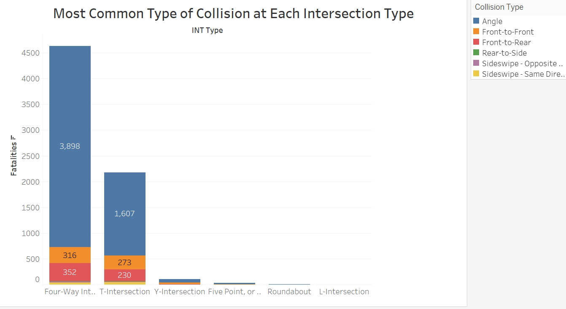

This stacked bar chart records the number of fatal collisions at each intersection type and subdivides them by type of collision. There are six different types of intersections included in this visualization. Each bar is then subdivided into collision types to measure the total number of fatal MVC’s at each type of intersection. The colors represent collision type. Since the purpose of this visualization was to measure the count of traffic fatalities at each intersection, I did not include collisions that did not occur at an intersection or collisions where intersection type was unknown. Stacked bar charts are more compact than grouped bar charts making them less cluttered, easier to read, and more visually appealing. The downside to this visualization is that two attributes have thousands of fatalities while the other five have significantly less so it is difficult to see the count of collision type at a roundabout or a Y-intersection.

Four-way intersections are the most dangerous intersections by count of fatalities in MVC’s, followed by T-intersections. These are the most common types of intersections which is why they have the most fatalities out of all the intersections listed. These intersections may or may not have a traffic signal which would be important information when analyzing traffic safety data. The most common type of collisions that result in fatalities at four-way and T- intersections are angle collisions where vehicles collide at an angle. This includes a T-bone collision where a vehicle collides with the side of another vehicle at a 180-degree angle. This does not surprise me since vehicles cross paths at these intersections so it would make sense that angle collisions such as T-bone collisions are the most common type of collisions at these intersections.

Roundabouts tend to be the safest intersection since they have a low count of fatalities. Vehicle speed is slower when entering a roundabout than when driving through an intersection without one, which is the main reason why roundabouts are the safest type of intersection. Due to the nature of roundabouts, when vehicle collisions do occur, it is usually a sideswipe collision or a rear-end collision at low speeds, making it the safest intersection. L-intersections have the lowest absolute count of fatalities out of all the intersections on the list, but they are rare, and they are not a feasible solution when improving traffic safety since most roads cross paths with each other such as a four-way intersection. What this means is that traffic engineers cannot turn a T-intersection or a 4-way intersection into an L-intersection, but they can install a roundabout at high crash intersections depending on the traffic volume and number of lanes the road has.

Data Visualization 2

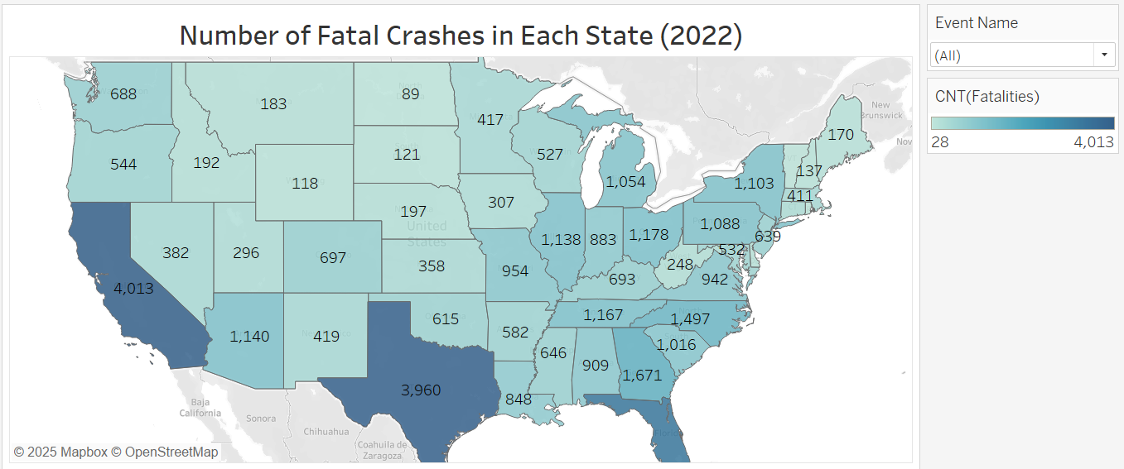
This visualization gives a count of the number of fatal MVC’s in each state in 2022 in the form of a map. A dropdown list for event name was added to make the visualization more interactive and two add more insights into the visualization. I also labeled each state with total count of fatalities resulting from a MVC in 2022, so users do not have to click on each state to see the exact number. I utilized color since users reading the map will not remember the exact count of fatalities in each state. The darker colored states have the most fatalities resulting from MVC’s while the lightest colored states have the lowest fatalities. Users can get a general idea of which states are the most dangerous or safest for motorists although this map does not take into consideration the population of each state.
The darker colored states such as Texas or California have the most fatal MVC’s and the lighter states such as Maine have the lowest count of fatal MVC’s. This visualization may be more useful if it divided count of fatal MVC’s by total population for the state to get rate of fatal MVC’s, but state population was not included in the dataset. California had the most fatal MVC’s followed by Texas and Florida. This does not surprise me because California and Texas are large states that have large population counts and Florida is a densely populated state. Furthermore, these three states have a large immigrant population and a high count of motorists that do not have a valid driver’s license, which is a safety concern (Unlicensed Drivers Responsible for 20 Percent of All Car Accidents, n.d.).
The dropdown menu on the right adds more context to this dataset as it shows the count of event names in each state. Event name refers to what the vehicle collided with such as a tree or the cause of the accident such as a rollover. For example, there were only three states where a collision with a live animal resulted in at least one death. In Ohio, seven deaths were caused by a collision with a live animal, eight for Oklahoma, and 18 for Texas. This may be useful in states where deadly collisions with wildlife are common such as Texas as signs warning motorists of farm animals or wildlife can be installed. This solution would not be useful in states where MVC’s with live animals are uncommon, which is why the event name dropdown list is important when analyzing the crash data. To improve this visualization even more, there can be a count of fatal MVC’s for every county, but it would be difficult to interpret an entire map of the U.S. subdivided by tiny counties.

Data Visualization 3
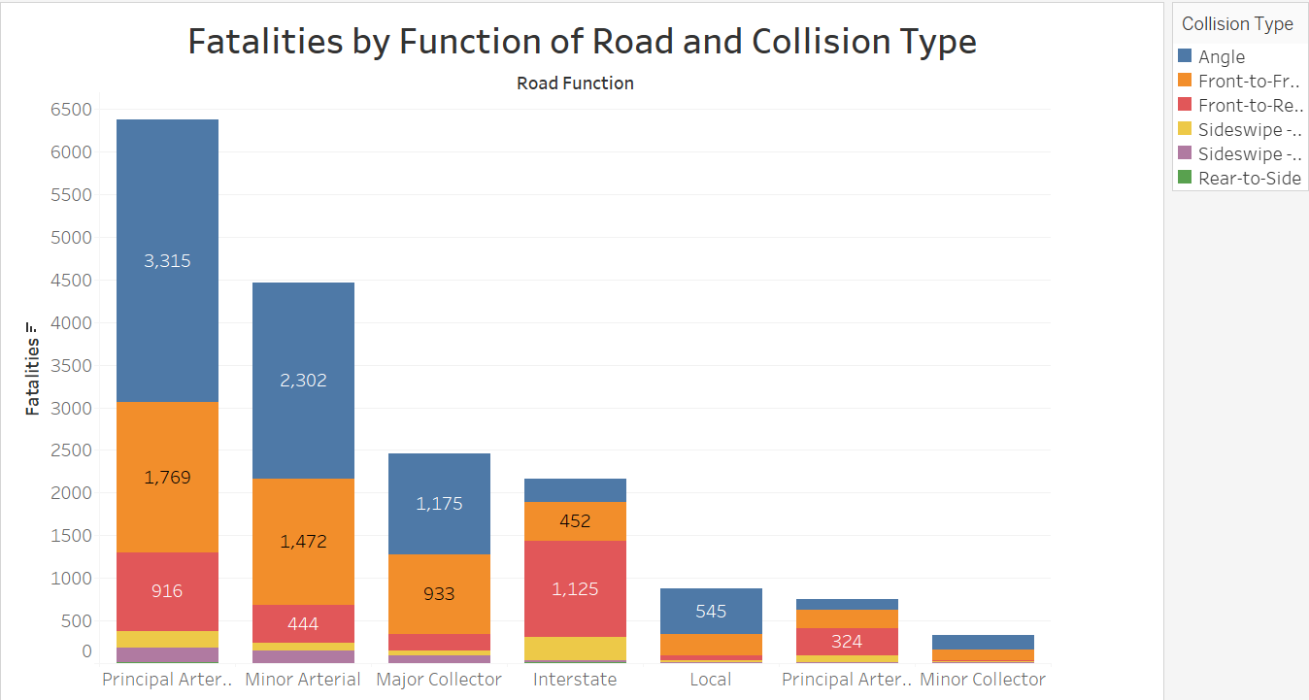
Visualization three is composed of a stacked bar chart measuring the effect of road function and collision type on count of fatal MVC’s. Therefore, the purpose of this visualization is to see which type of collision combined with road function results in the most fatalities. I excluded all collision types in which the collision type was unknown, and I excluded collision types that did not occur with another motor vehicle to see which collision types involving two or more vehicles are the most dangerous. Each collision type is color coded to distinguish each type of collision. Road function is an important variable when analyzing fatal motor vehicle collisions because it gives insights into which road designs are the safest and which road designs have a lot of MVC’s. This visualization was originally a stacked bar chart but it was cluttered and hard to read which is why it was converted into a stacked bar chart.
Arterial routes are major thoroughfares that connect collector roads to highways and are designed for higher vehicle speeds. Roadways that are designed for high speed but have many businesses and intersections along them such as arterial routes that tend to have more fatal MVC’s since there are more potential points of conflict and the vehicle speeds are higher with two or more lanes in each direction which results in more fatalities. Conflict points are places where vehicles cross paths or merge such as a parking lot, intersection, roundabout, or merge area on a freeway. Although vehicle speed is a significant factor in fatal MVC’s, high speed roadways such as freeways and interstates are safer than principal arterial routes because there are less conflict points on freeways and interstates. For this reason, interstates have less fatal MVC’s than arterial routes.
When analyzing the type of collision that results in the most fatalities, the road function is a big contributing factor which is why included a bar chart categorized by collision and route function. Routes such as interstates have rear-end collisions as the collision type that results in the most fatalities but in arterial routes, angle collisions result in the most fatalities. This is because vehicles travel along a straight line at high rates of speed on interstates, so it would make sense that rear end collisions result in the most fatalities on an interstate. There are more intersections and turning vehicles on arterial routes which is why angle collisions result in the most fatalities along arterial routes. Angle collisions include T-bone collisions where one vehicle collides with another vehicle at a 180-degree angle. In this type of collision, the driver or passengers on the side of the vehicle that got struck have a lower chance of surviving the higher the vehicle speed which is why angle collisions have the overall highest fatality rate.

‌

Data Modeling
Assignment 4

Data Modeling Definitions
The two models that will be used are a decision tree model and a naïve bayes model. Both of these models are supervised learning models used for classification problems. A decision tree starts with a root node which is the most important attribute which then feeds into decision nodes. The leaf nodes at the bottom of the tree classify the decision nodes into a class. Decision trees use a divide and conquer strategy where it identifies the optimal split points within a tree and repeats this process until all records have been classified under specific class labels (What is a Decision Tree?). The advantages that decision tree models have are their ability to find non-linear relationships in data, they are easy to interpret and explain how they predict the collision type.
Naïve Bayes is a probabilistic classification method grounded in Bayes Theorem, simplifying the modeling process by assuming input variable independence (Li, 2024). What this means is that Naïve Bayes models assume that one independent variable does not influence the other independent variable and are therefore independent of each other. Advantages that Naïve Bayes models have is their scalability as they only need a few input parameters that increase linearly with the number of predictors (Li, 2024). In this project, the model will take the predictor variables and classify the type of collision that occurred based on the variables. The downside to using a Naïve Bayes model is that since the input variables are independent of each other, the results may not be as accurate since some features may be correlated. However, Naïve Bayes models can have more than two target class groups, and they are easier to set up which is why a Naïve Bayes model was used over a support vector machine.
The goal with these two models is to predict the type of collision based on features the model is given. Collision type will be the target variable instead of number of fatalities because most collisions in the dataset only resulted in one fatality so the model would likely overfit and predict one fatality for each instance. Furthermore, since the most fatal collision types are known, knowing the type of collision and its contributing factors may be useful in preventing future collisions. If traffic engineers know the most common type of collision given the key variables that contributed to it, they can make adjustments to reduce that specific type of collision. For example, if there is a high count of angle collisions at a 4-way intersection, traffic engineers may install a roundabout depending on traffic volume, install a protected left turn lane, or eliminate turns entirely to address the number of angle collisions. Therefore, knowing the type of collision is more informative than the number of fatalities when it comes to making changes since other extraneous variables can affect the number of fatalities such as the number of people involved, or the number of vehicles involved.

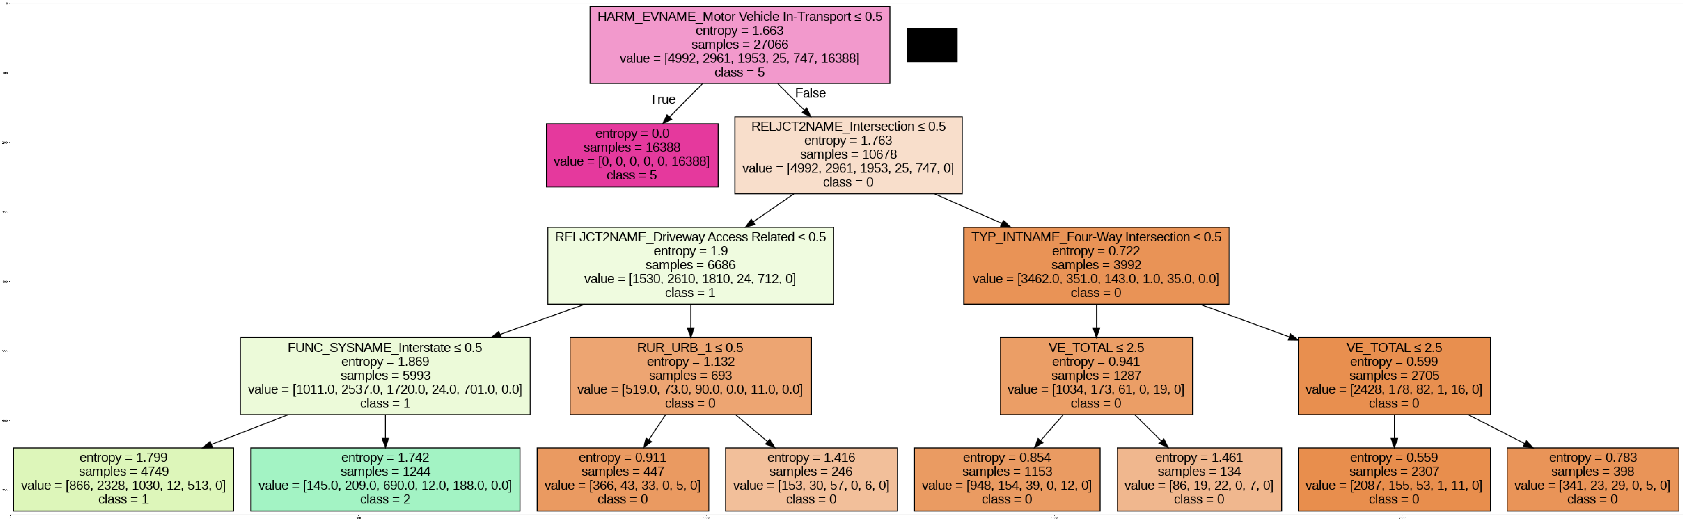
Data Model 1

This decision tree classifies the collision type of each collision based on its contributing factors such as road function, intersection type, vehicle total, if it occurred in a rural or urban area, or where on the road the collision occurred (REJECT2NAME). Since this model only uses continuous variables, all categorical variables were converted to discrete variables. The training and testing data points were then split so that 80% was used for testing and the remaining 20% was used for training.
When analyzing the tree, the root node was HARM_EVNAME vehicle in transport <= 0.5. The root node affects all of the model’s predictions, so harm event name is the most feature in this decision tree. The most influential attribute of HARM_EVNAME was motor vehicle in transport meaning a collision where another motor vehicle in transport is struck effected all the following decisions. If HARM_EVNAME motor vehicle in transport <= 0.5, then the tree predicted that the collision type was no collision with another vehicle. This means that if the cause of the collision did not involve another vehicle in transport, then it was automatically assigned to “the first harmful event was not a collision with a vehicle in transport”. The most influential attributes following HARM_EVNAME motor vehicle in transport are REJECT2NAME_intersection <= 0.5. If the collision occurred at a 4-way intersection, then the decision tree predicted that the collision was an angle or T-bone collision. If a collision occurred near a driveway access, the model also predicted the collision to be an angle/T-bone collision. Lastly, if the collision occurred on an interstate, then the decision tree predicted that the collision was most likely a rear-end collision which seems like the most likely scenario since there are not a lot of opportunities for angle collisions or head on collisions on interstates.
The decision tree had an accuracy score of 86.5 percent so it is an accurate model. However, the average precision and recall scores were 0.47 and 0.46 respectively. A precision score of 0.47 means the models positive predictions were correct 47% of the time, so about half of the positive predictions were false positives. A recall score of 0.46 means the model is generating false negatives as well since recall is the model’s ability to identify true positives. Reasons why the recall and precision scores are low may be because of too many attributes in the dataset. Since the target variable classes were not evenly distributed, the model was less likely to predict the collision types that result in the least number of fatalities such as rear to side or sideswipe. Furthermore, having too many attributes may increase the difficulty for the model to find patterns in the data, especially if there are many classes for each variable.

Data Model 2

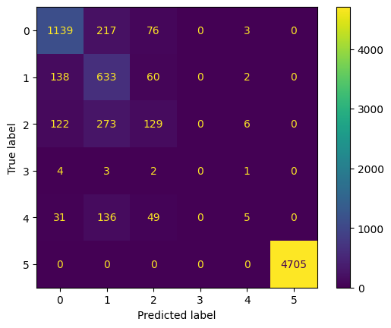

The Naïve Bayes model had an accuracy score of 85.5% so it has good accuracy. Since there were only 35 rear to side collisions in the entire dataset, the model did not predict any of the data points to be rear to side collisions. Most of the model’s incorrect predictions were head on collisions according to the confusion matrix. 217 angle collisions were incorrectly predicted as head on collisions, 273 rear end collisions were incorrectly predicted as head on collisions, and 136 sideswipe collisions were incorrectly predicted as head on collisions. The model was 100% accurate at predicting collisions where the first harmful event was not a collision with another motor vehicle. This is because variables such as HARM_EVNAME which records what the vehicle struck. If the harmful event did not involve another motor vehicle in transport, then the model assumed that the collision did not involve another motor vehicle.

Although there were a lot of false negatives for rear to side and sideswipe collisions, it is better for there to be more false negatives than false positives for these data points since these collision types are rare in the dataset. Model. There were only 35 rear to side collisions in the entire dataset and only 10 of them were in the testing set. Since the dataset was also heavily composed of angle collisions and head-on collisions, the model had a lot of false positives for those two categories. However, the collision types that had a lot of false negatives such as rear to side or sideswipe are less deadly which is why there are less of them in the dataset. After reading the confusion matrix, the top three most deadly types of collisions were collisions where the first harmful event was not a collision with another motor vehicle, an angle collision, and a head on collision. The next step would be to find the locations where these types of collisions are most common. According to the decision tree, angle collisions are most commonly found at four-way intersections and rear end collisions are most common on interstate highways.

Review of Data Models
When comparing the accuracy score of both models, the decision tree model was more accurate by only 1% (86.5%). Both models had a hard time predicting collision types that did not have a lot of representation in the dataset. That is not necessarily a negative since those collision types result in significantly less fatalities compared to collision types such as angle or head-on. Therefore, the precision score for rear to side collisions and sideswipe collisions had low precision scores meaning they had a lot of false negatives.

Overall, the decision tree is a better model than the Naïve Bayes model because it has a higher accuracy score, and it has more explainability than the Naïve Bayes model. The decision tree uses a tree-like diagram to explain its decision process when classifying collision types. Explainability is important because it explains the contributing factors to each collision type so solutions can be found. For example, angle collisions were most commonly found at 4-way intersections. Having this information, traffic engineers can find specific 4-way intersections that are “hotspots” for collisions and make adjustments such as installing a roundabout, adding a protected left turn arrow at a signalized intersection, or eliminating turns entirely at intersections that have a lot of angle collisions. The decision tree also predicted that rear end collisions are commonly found on interstates. This makes sense because vehicles travel at higher speeds on interstates, so they have less time to stop increasing the likelihood of rear ending the vehicle ahead of them. Furthermore, interstates are divided highways with limited access, making head on collisions and angle collisions rare on interstate highways. With this information, municipalities can enforce a safe following distance between vehicles and increase the fines for speeding in order to reduce the number of rear end collisions. Angle collisions can possibly be reduced at driveway access points by lowering the speed limit or by installing signs alerting motorists of turning vehicles from driveways. Therefore, the decision tree is the best model because it is more accurate, and it explains the most influential factors that influence the model’s decisions.

Final Results
Assignment 5

Findings
After completing this project, the main findings are that the type of collision has a significant effect on the number of fatalities, while intersection type and road function also have a significant effect on number of fatalities. Interestingly, most collisions in the dataset that resulted in a fatality did not involve another motor vehicle. There are multiple reasons why this may be the case. The first reason behind this is because most collisions do not involve another motor vehicle so there are a higher count of fatal collisions that do not involve another motor vehicle by default. The other reason why most collisions do not involve another motor vehicle is because dangerous collisions such as a pedestrian getting struck or a vehicle rollover do not involve another vehicle. Collisions where a tree is struck also do not involve another vehicle. Since fully frown standing trees do not absorb impact force, they are a deadly object to collide with.
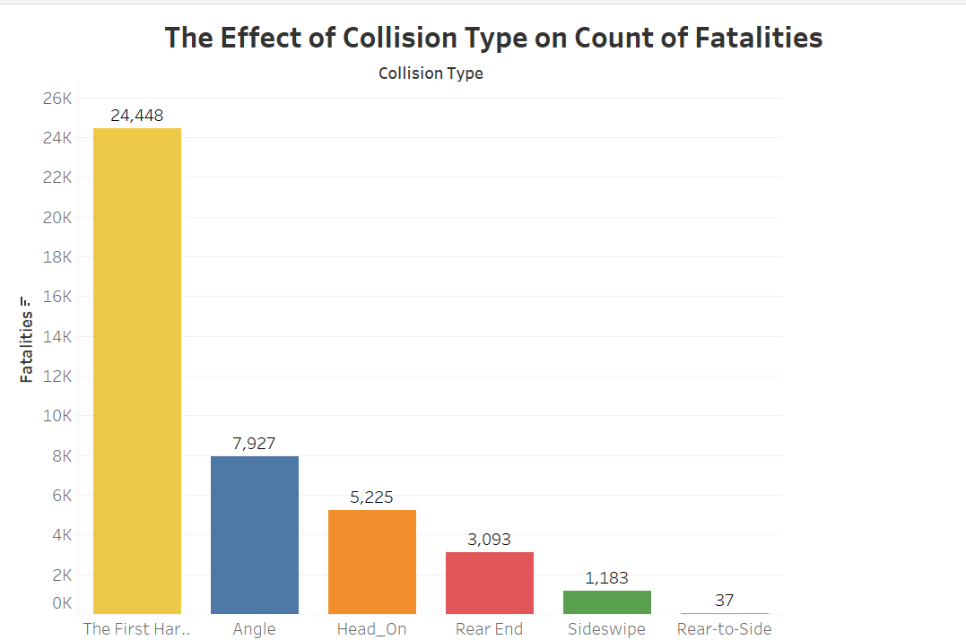
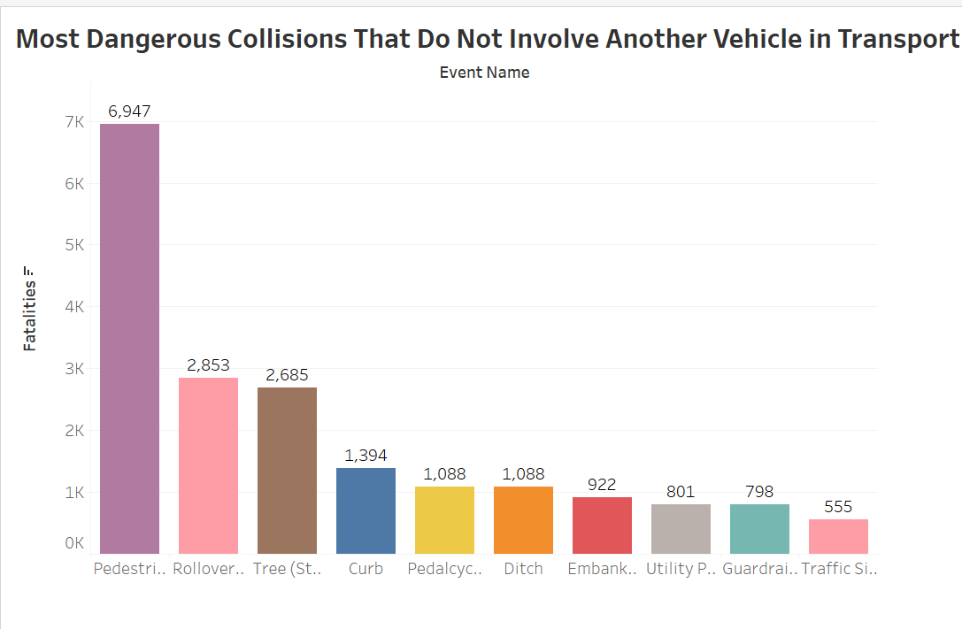
When analyzing collisions that did involve another motor vehicle in transport, angle collisions had the highest count of fatalities followed by head-on collisions. Although, angle collisions had the highest count of fatalities, they are more common than head on collisions which is why they have the highest count of fatalities. Angle collisions, or T-bone collisions are likely to occur on roads that have many intersections and turning vehicles such as an arterial route. Since these routes are commonly found across the United States, there are a lot of angle collisions that result in at least one fatality. Head on collisions are collisions where two vehicles collide head-to-head. These collisions are less common than angle collisions but are arguably more dangerous since there is significantly more impact force when two vehicles traveling in opposite directions at high speed collide with each other.
When it comes to analyzing the effects of intersection type and road function on count of fatalities, 4-way intersections and principal arterial routes result in the highest count of fatalities. This makes sense because four-way intersections are the most common type of intersections and there is a high potential for angle collisions at four-way intersections with unprotected left turns. Many rural highways with high-speed traffic have four-way intersections with no traffic signals, so motorists must be cautious when making left turns. Furthermore, principal arterial routes which have multiple lanes and have many businesses along them also have a high number of unprotected turns, significantly increasing the likelihood of their being an angle collision. The roads with the lowest fatality counts are minor collectors, local roads, and interstates. Vehicle speed is lower on local roads and minor collectors, so drivers have more time to react and when a collision does occur, there is less impact force. Freeways and interstate highways don’t have any cross traffic or vehicles turning, so there is less potential for collisions on interstates. Therefore, roads that have many intersections and turning vehicles where vehicle speed is high such as arterial routes have the highest count of fatalities compared to other road functions.
The decision tree model and Naïve Bayes model confirmed the findings above. Both models predicted that collisions not involving another vehicle in transport have the highest fatality count, and angle collisions had the highest fatality count out of collision types that do involve another vehicle in transport. According to the decision tree model, four-way intersections were a significant contributor to angle collisions. The model also predicted that driveway access points were also significant contributor to angle collisions. Lastly, the decision tree model predicted that rear-end collisions resulting in at least one fatality are most likely to occur on interstates. The model’s predictions make sense because four-way intersections and driveway access points have a lot of potential for there to be an angle collision since there are turning vehicles. Interstates have a lot of potential for there to be rear-end collisions because vehicles travel at high speeds and if vehicles don’t maintain a safe following distance, there is a high likelihood of a rear-end collision taking place, especially with heavy traffic volume.
Some other attributes that were researched were light conditions. More collisions occurred after dark as opposed to daylight. Furthermore, collisions resulting in at least one fatality were more common at dark unlit areas than dark areas that were lighted, which makes sense because there is less visibility in dark areas with no streetlights. There were also a lot of collisions that occurred during daylight hours but there is considerably more traffic during the day than at night so it would make sense that there are a high number of MVC’s during daylight hours. There are a higher count of MVC’s when it is dark and a significantly higher proportion of collisions when it is dark outside since there is less traffic. However, it gets dark out earlier in the winter so it is likely dark outside during rush hour traffic which may explain why there are more collisions that result in a fatality when it is dark outside. Knowing where collisions occurred in dark unlit areas may be useful because streetlights can be installed at locations that have a high count of collisions in dark unlit areas.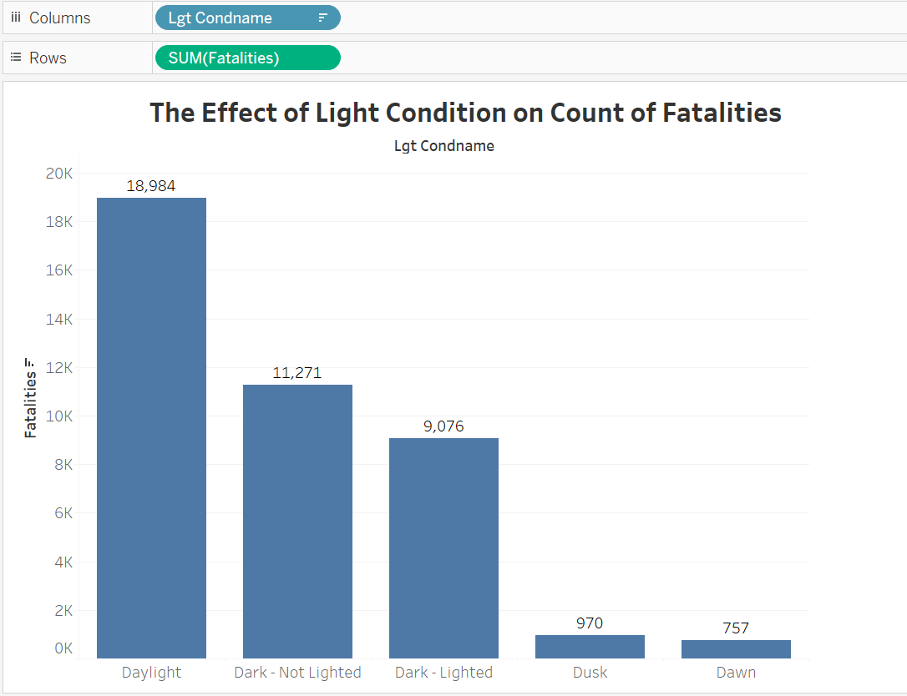

Lastly, the road location and the most common days that the collisions occurred were analyzed. The two most common part of the road that collisions occur on are on the actual roadway. Since most collisions with another vehicle that result in at least one fatality occur at intersections, collisions that occur on the roadway have the highest counts of fatalities. According to the Federal Highway Administration, 50% of all collisions that result in an injury occur at an intersection (“Where do Most Car Accidents Happen”, 2025). Interestingly, Friday – Sunday had the highest count of collisions that resulted in at least one fatality although there are a higher count of total collisions on weekdays (“Where do Most Car Accidents Happen”, 2025). Since people travel to work or school on weekdays, it would make sense that there are more collisions on weekdays. However, more people travel longer distances on weekends than during weekdays which is why Friday – Sunday has the highest count of motor vehicle collisions resulting in at least one fatality.
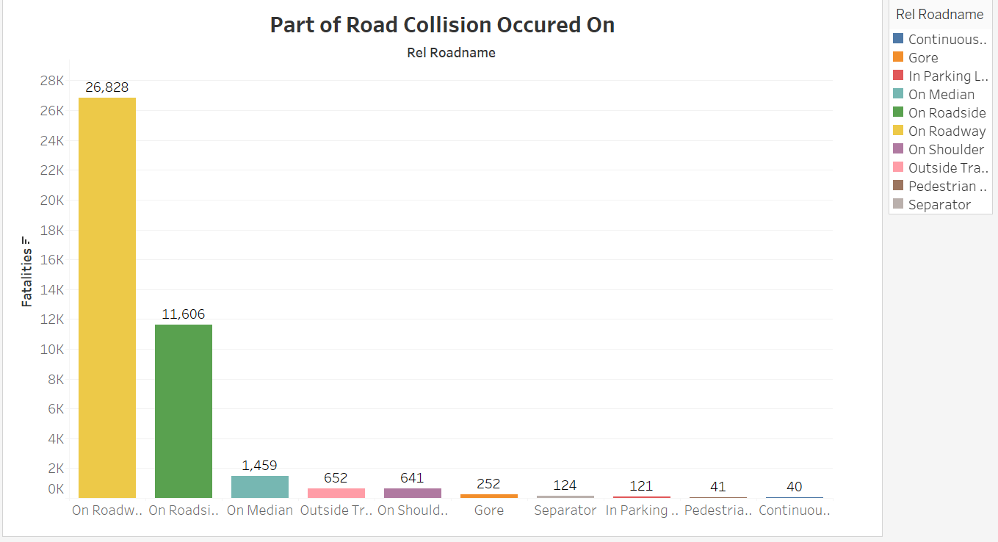
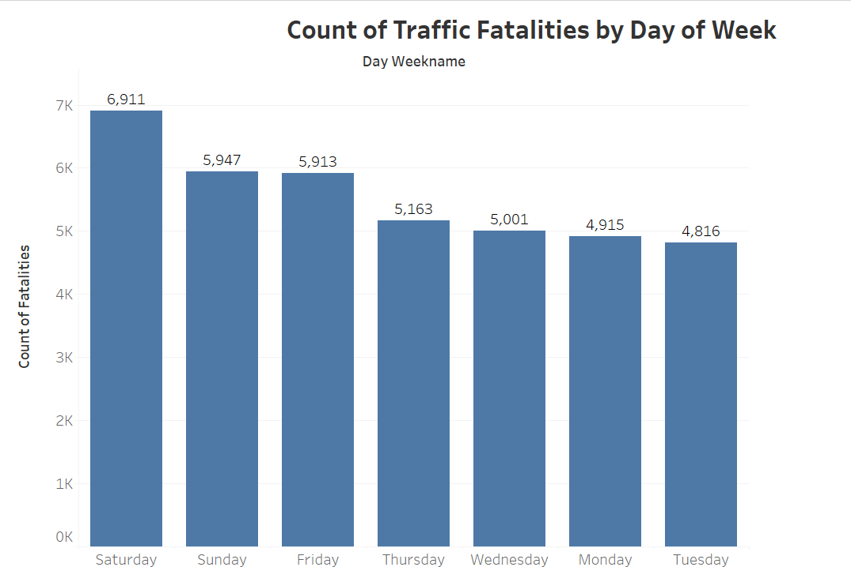

Review of Success or Completion
I was successfully able to find adequate background information on the topic of fatal motor collisions and establish the importance of the dataset. Important preliminary questions were considered such as the primary goal of the project, who will benefit from the project, and is the data sufficient to meet the project’s goals (Al-Taie et al., 2017). After doing background research, the dataset was analyzed and then cleaned. In this step, a few columns were removed that were either duplicates of another column or were not relevant to what was going to be measured. Each column had some values reported as unknown, so most unknown values were kept for each column but were excluded when researching a specific variable. When creating a visualization of the most common collision type at each intersection, collisions reported as unknown were not included on the bar chart. Visualizations that displayed the combined effect of intersection types and collision types on the count of fatalities as well as the effects of collision types and road function on count of fatalities were created in Tableau.

After creating the visualizations, a Naïve Bayes model and decision tree model were developed to answer research questions. In this project, the target variable that the model is predicting is the collision type and the variables that had the most influence on specific collision types. Models predicting the number of fatalities were originally going to be developed but they had low accuracy and MSE scores since over 90% of collisions in the dataset resulted in only one fatality, so the model was unable to accurately predict collisions that result in more than one fatality. Furthermore, developing a model that can predict the collision type is more useful because knowing the variables that contribute to a specific collision type will give traffic engineers more valuable information than count of fatalities alone. There are many extraneous factors for a traffic fatality such as EMS arrival time, and having too many attributes may hinder the models ability to find patterns in the data. The decision tree and Naïve Bayes models had accuracy scores of 85 and 86 percent, so they were much more accurate than the linear regression model and decision tree regressor which predicted the number of fatalities. The only problem with the Naïve Bayes model was that it was unable to predict any rear-to-side collisions because there were only thirty-five of those collision types out of the 38,000+ rows in the dataset. Rear-to-side collisions rarely ever result in a fatality since most of these collisions occur in a parking lot where vehicle speeds are low.

Limitations to this project were that I was unable to find collision “hotspots”, or specific locations that had multiple collisions with at least one fatality. Doing so would require data collected over a period of multiple years to find these trends. The dataset this project is analyzing only contains data 2022, so there are not enough data points to see specific locations.

Potential Data Privacy and Data Security Issues
Although there is no personal identifiable information in the dataset, the organization conducting the collision report must take steps to ensure that the data is secure. Steps taken to safeguard data collected in the collision report are encryption, so the data remains secure at all times (Lukhi, 2023). Other steps taken include obfuscation, which hides sensitive information from view (Lukhi, 2023). Consequences of selling data on the collision to third parties such as attorneys, medical providers, or repair shops are the people involved in the collision may receive unsolicited phone calls advising them of their “right to collect money from their accident” (Smith, 2018). This can lead to frustration among the individuals involved in the collision and distrust in the local government. Furthermore, parties involved in the collision may have the option to sue the agency that collected and sold their data (Smith, 2018). A law in 1994 called the 1994 Drivers Protection Act was passed to prohibit anyone from disclosing personal information in the crash report without the consent of the individuals whose information is being collected (Smith, 2018).

Potential data privacy issues related to the NHTSA dataset and how the results of the model are used are a concern. The results from the decision tree model can be used to improve road safety but the data may be misused and there may be unwanted consequences at the same time. Local law enforcement agencies may rely on the sale of data from crash reports as cash strapped police departments may use this data to fund anti-crime efforts (Smith, 2018). These anti-crime efforts may target low socioeconomic areas and minority communities that have a high number of collisions in the dataset. In the case of using data from collision reports, the police may set up more speed traps where there are a high count of collisions resulting in a fatality. Individuals who use roads with speed traps set up on their daily commute may feel like they are being unfairly targeted by the police department. Furthermore, individuals may argue that speed traps don’t discourage speeding if motorists do not know there are speed traps set up. Therefore, other means to reduce vehicle speed should be used when the goal is to reduce speeding. Doing so can reduce the number of vehicle collisions while not undermining the public’s trust in law enforcement.

Recommendations for Future Analysis
For future analysis, a dataset with collisions that did not result in any fatalities should be used and compared with the dataset used in this project. Doing so will allow analysts to find key factors that result in a collision being fatal. Since the dataset used in this project only included collisions that resulted in at least one fatality, there was no way to distinguish between collisions that resulted in a fatality and collisions that did not. Furthermore, most collisions in the dataset only had one fatality so building a model that can predict the number of fatalities for each collision would be impossible since the model would overfit and predict one fatality each time. Half of the collisions should be collisions resulting in at least one fatality, on the other half should be collisions not resulting in any fatalities. This would allow the target variable to be evenly distributed so there is no bias in the models results.
Another recommendation would be to find specific locations in each state where there are a high number of collisions that result in at least one fatality. This could be a specific intersection or stretch of road where there were a high number of collisions within the past few years. With this information, researchers can then look into the main causes of the collisions at each specific location. For example, a traffic signal at an intersection may have poor visibility for drivers making a left turn, resulting in a high count of angle collisions. Having this information will allow engineers to make necessary changes and implement a protected left turn lane. For this to be successful researchers should use datasets from the past few years to get a better sample size of where most collisions take place because the current dataset only contains data from 2022.

References
Please provide at least 3 references in APA format which are cited for each assignment.
Al-Taie, M. Z., Salim, N., & Obasa, A. I. (2017). Successful Data Science Projects: Lessons Learned from Kaggle Competition. Kurdistan Journal of Applied Research, 2(3), 40–49. https://doi.org/10.24017/science.2017.3.18
Blincoe, L., Miller, T., Wang, J.-S., Swedler, D., Coughlin, T., Lawrence, B., Guo, F., Klauer, S., & Dingus, T. (2023, February). The economic and societal impact of motor vehicle crashes, 2019 (Revised) (Report No. DOT HS 813 403). National Highway Traffic Safety Administration
CDC. (2024, May 17). About Transportation Safety. Transportation Safety. https://www.cdc.gov/transportation-safety/about/index.html
Chirag Lukhi. (2023, September 19). Privacy and Security Considerations in Crash Reporting - Shakebug - Blog. Shakebug - Blog. https://www.shakebug.com/blog/privacy-and-security-in-crash-reporting/
Dadashova, B., Boutros, A., Reyes, D., Schoner, J., Sanders, R., Chiovenda, M., Lee, C., Zhu, C., Wang, O., Elgart, Z., Eisert, J., & Panik, R. (2024). Exploring Risk Factors to Disparities in Pedestrian and Bicyclist Fatalities and Serious Injuries [Review of Exploring Risk Factors to Disparities in Pedestrian and Bicyclist Fatalities and Serious Injuries]. U.S. Department of Transportation Federal Highway Administration, 1–123. Repository & Open Science Access Portal. https://doi.org/10.21949/1521546
Desai, N., & Patel, V. (2021). Linear Decision Tree Regressor: Decision Tree Regressor Combined with Linear Regressor [Review of Linear Decision Tree Regressor: Decision Tree Regressor Combined with Linear Regressor]. Gujarat Technological University.
Fletcher, S., & Islam, Z. (2019). Decision Tree Classification with Differential Privacy: A Survey [Review of Decision Tree Classification with Differential Privacy: A Survey]. ACM Computing Surveys, 52(4), 1–33. ACM Digital Library.
IBM. (2021, November 2). What Is a Decision Tree? Ibm.com. https://www.ibm.com/think/topics/decision-trees
Indratmo, Howorko, L., Boedianto, J. M., & Daniel, B. (2018). The efficacy of stacked bar charts in supporting single-attribute and overall-attribute comparisons. Visual Informatics, 2(3), 155–165. https://doi.org/10.1016/j.visinf.2018.09.002
‌Li, F. (2024). Novel Data-Driven Machine Learning Models for Heating Load Prediction: Single and Optimized Naive Bayes. International Journal of Advanced Computer Science and Applications, 15(8). https://doi.org/10.14569/ijacsa.2024.0150866
NHTSA. (2022). NHTSA. https://www.nhtsa.gov/file-downloads?p=nhtsa/downloads/FARS/2022/National/
Retting, R. A., Ferguson, S. A., & McCartt, A. T. (2003). A review of evidence-based traffic engineering measures designed to reduce pedestrian-motor vehicle crashes. American journal of public health, 93(9), 1456–1463. https://doi.org/10.2105/ajph.93.9.1456
Smith, M. (2018, March 2). Selling Crash Report Data May Not Be Legal [Review of Selling Crash Report Data May Not Be Legal]. PropertyCasualty360. https://www.propertycasualty360.com/2018/03/02/selling-crash-report-data-may-not-be-legal/
Stewart, T. (2023, April). Overview of motor vehicle traffic crashes in 2021 (Report No. DOT HS
813 435). National Highway Traffic Safety Administration.
‌
Unlicensed Drivers Responsible for 20 Percent of All Car Accidents. (n.d.). USClaims Financial Support | a Pre-Settlement Funding Firm. https://usclaims.com/educational-resources/non-licensed-drivers-responsible-for-20-percent-of-all-auto-accidents/
U.S. Department of Transportation. (2023, February 2). The Roadway Safety Problem | US Department of Transportation. Www.transportation.gov. https://www.transportation.gov/NRSS/SafetyProblem
Wada, K., Wallner, G., & Vos, S. (2022). Studying the Utilization of a Map-Based Visualization with Vitality Datasets by Domain Experts. Geographies, 2(3), 379–396. https://doi.org/10.3390/geographies2030024
(2025, March 23). Where Do Most Car Accidents Happen? [Review of Where Do Most Car Accidents Happen?]. Alabama Injury Lawyer. https://www.alabamainjurylawyer.com/blog/where-do-most-car-accidents-happen/#:~:text=Intersections,following%20intersections%20see%20frequent%20crashes:
‌

‌

